

Course Title: Computer-Aided Engineering Drawing
Course Code: CSE200 Section: 4

Mini Project

Topic:
1. MARS Rover or Space Rover in 3D
2. Armored Vehicle 3D
3. Fighter Jet in 3D

Prepared by –
Md. Sarafat Alam Mozumder
2022-3-60-061

Instructor –
Md Al-Imran
Department of CSE
Mars Rover

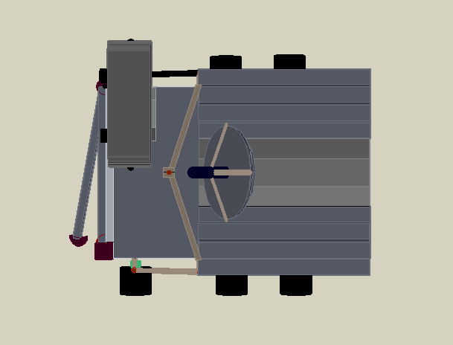 | 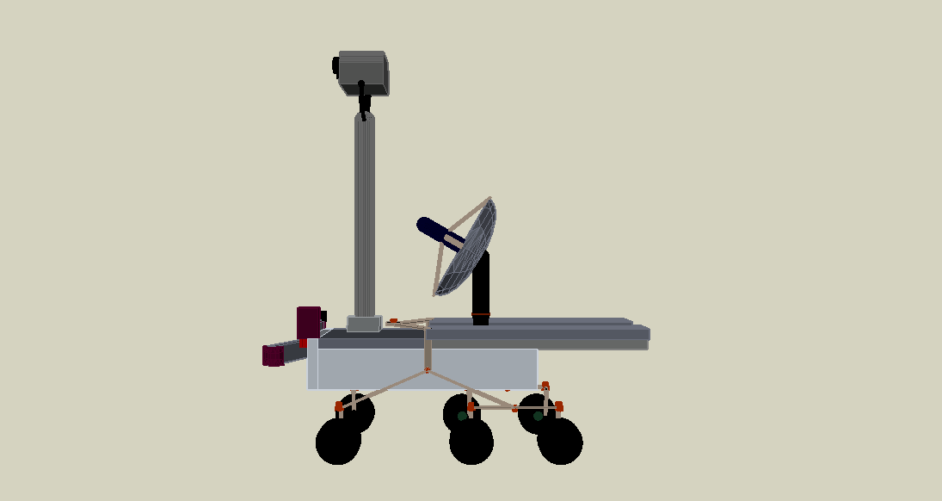 | 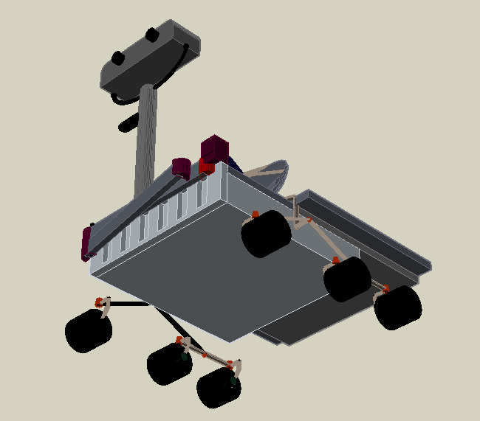
Top | Side | Bottom
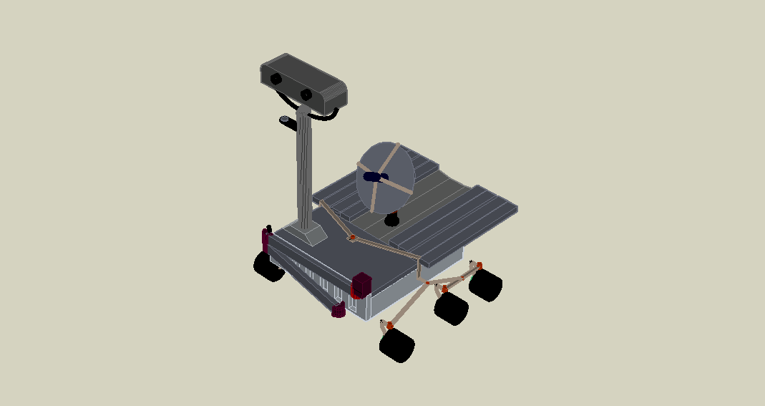
Armed Vehicle

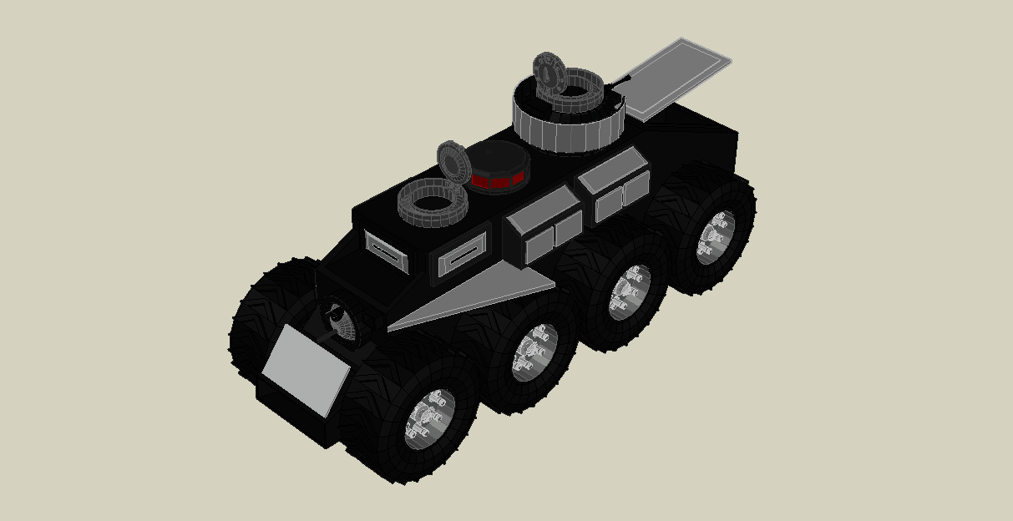
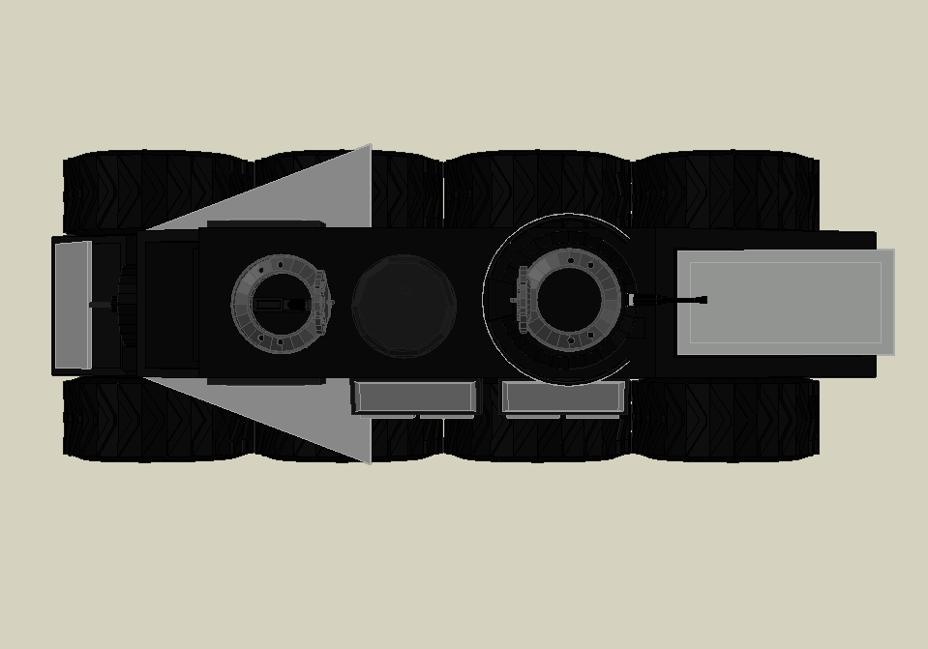 | 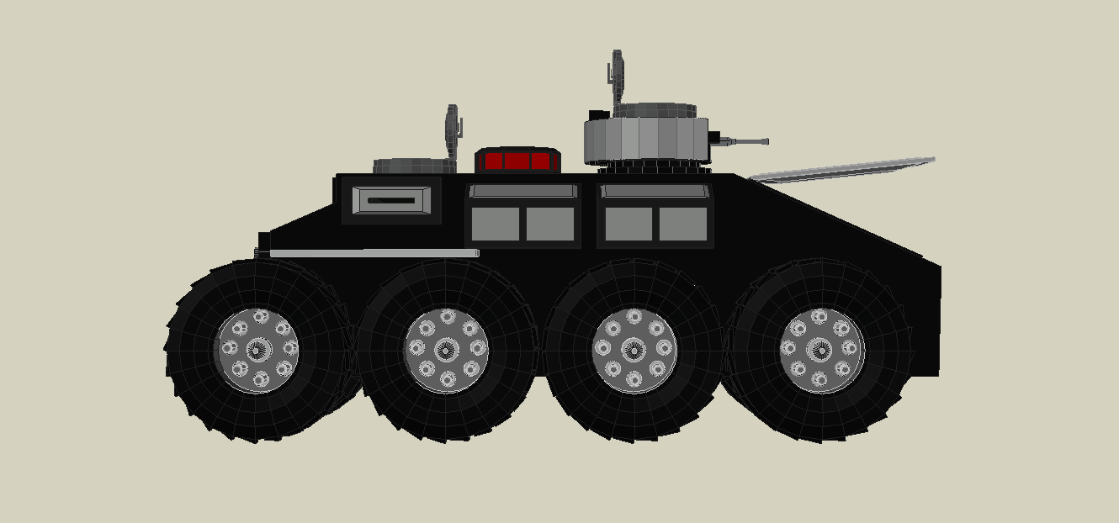 | 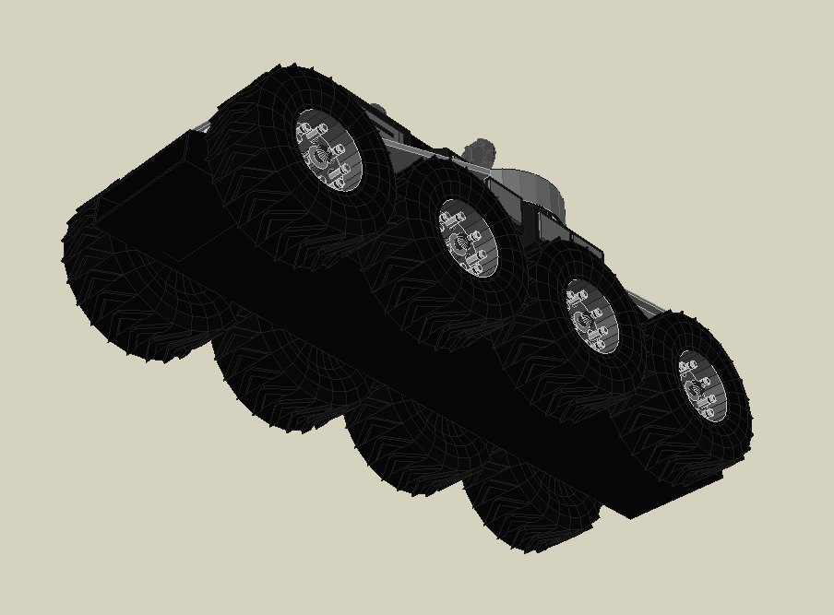
Top | Side | Bottom

Fighter Jet 3D

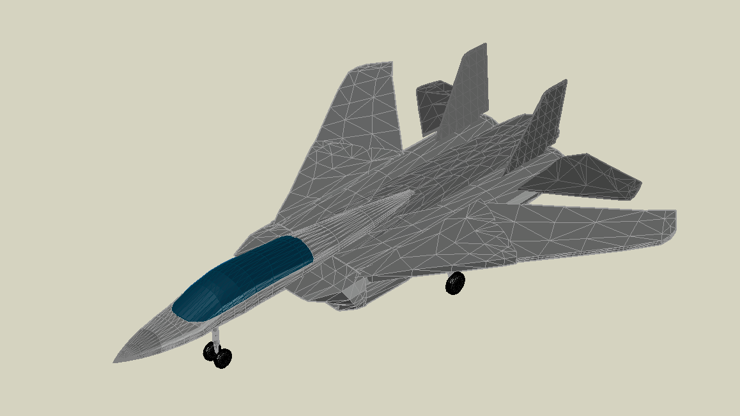

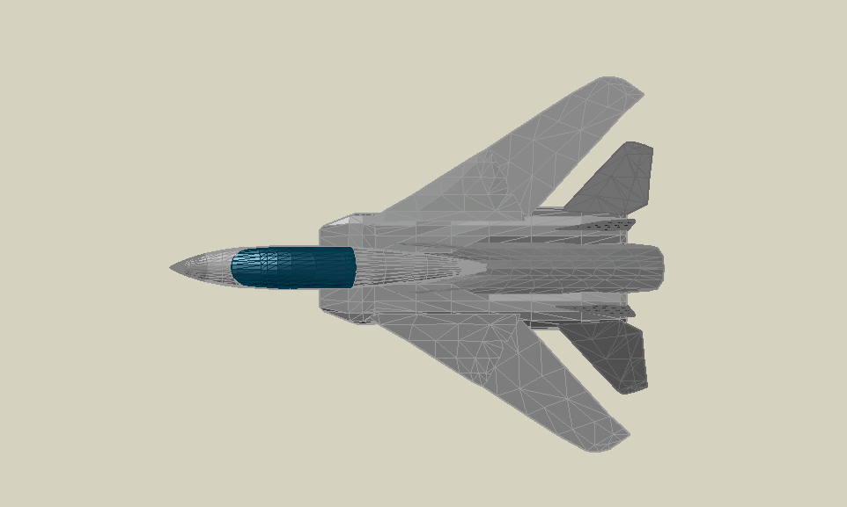 | 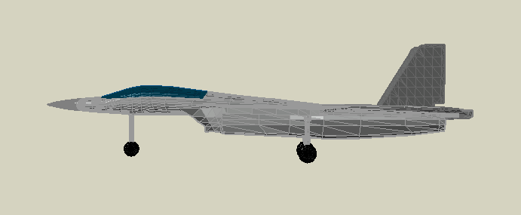 | 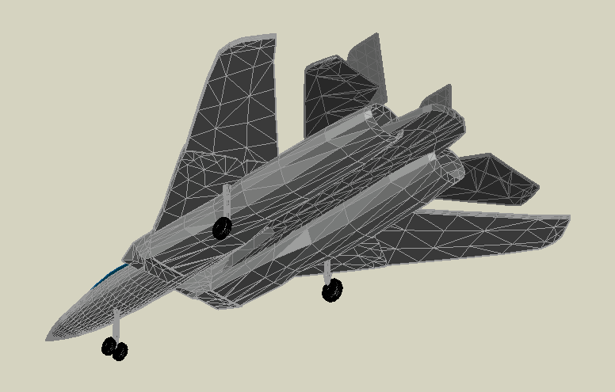
Top | Side | Bottom

